SmartBear TestComplete License Activation:

About

[Floating User](https://support.smartbear.com/testcomplete/docs/licensing/key-based/license-types.html) licenses permit running TestComplete by multiple concurrent users. The license is controlled by the **License Manager** utility. You typically install it on a computer that has no TestComplete or TestExecute installed on it.

You activate a Floating User license once – on the License Manager computer. There is no need to activate it on each workstation that TestComplete will run on.

1. Download and install the License Manager utility

1. Select a computer for the License Manager utility

The License Manager is a lightweight utility that can run on any (even ”weak“) computer. The minimal system requirements look like these:

* Windows 7 SP1 or later operating system (both Client and Server editions are supported)
* 2 GB of RAM
* 200 MB hard drive space
* 1024 × 800 or higher resolution monitor
* Network interface (see below)

 After you activate your license on some computer, it becomes bound to that computer. To move your license to another machine, you will have to deactivate the license. You may need to contact the SmartBear Sales Team. To save time and to avoid unnecessary moves of the license in the future, we recommend that you select a License Manager computer carefully. There are some ***important requirements*** to the network settings and availability of that computer:

[[](javascript:ShowExample(%221--download-and-install-the-lice-1--select-a-computer-for-the-lic_sectionbody1_example1_id%22,%20%221--download-and-install-the-lice-1--select-a-computer-for-the-lic_sectionbody1_example1_div%22))View requirements](javascript:ShowExample(%221--download-and-install-the-lice-1--select-a-computer-for-the-lic_sectionbody1_example1_id%22,%20%221--download-and-install-the-lice-1--select-a-computer-for-the-lic_sectionbody1_example1_div%22))

* Your License Manager PC should be a physical computer. We don’t recommend activating licenses on virtual or cloud machines. If you use them, you will need to ensure that their MAC address and CPU data don’t change after that machine restarts.
* It must always be available to workstations where TestComplete instances will run. That is why we recommend that you activate Floating User licenses on the server computer.
* It must have a working network connection. TestComplete instances running in your network must be able to connect to it.
* This computer must allow traffic via the TCP and UDP protocols and port 1947. It will use these protocols and the port to exchange data with TestComplete instances.

 Make sure that firewalls and proxies running in your network do not block these protocols and ports.

* We also recommend that this computer has a functioning Web connection. In this case, it will be easier to activate the license on it. After the activation, the connection will not be needed.

To activate the license over the Web (*automatic activation*), the computer must have access to the SmartBear web server (URLs https://ls1.smartbear.com and http://ls2.smartbear.com, port 443). Make sure the proxies and firewalls working in your network allow the activation requests.

If the computer has no Internet connection, you will have to follow the *manual activation* steps. You will need an intermediate computer that has that connection and that you will use to exchange data with the SmartBear web server. That intermediate computer must have access to the SmartBear web server (URLs https://ls1.smartbear.com and http://ls2.smartbear.com, port 443).

For complete information on automatic and manual activation, see below.

2. Download and install the utility

You can download the utility from the SmartBear website:

[downloads.smartbear.com/SmartBearLicenseManager.exe](https://downloads.smartbear.com/SmartBearLicenseManager.exe)

To install the utility, simply run the downloaded executable and follow the instructions you will see on screen. The installation is easy and straightforward.

2. Activate the license

License activation includes the data exchange between the License Manager and SmartBear licensing servers. If the computer where you installed the License Manager has access to the Web and to the licensing servers, the license will be activated automatically. Else, you can activate it manually.

Automatic activation

1. Start the License Manager: click the operating system’s Windows button and select **SmartBear > Activate or Deactivate License** from the **All Programs** list.
2. On the first page of the wizard, select **Activate a new license on this computer**.

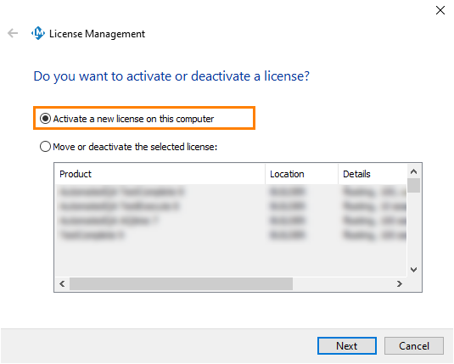

If your computer has an Internet connection and has access to the SmartBear licensing websites (https://ls1.smartbear.com or https://ls2.smartbear.com, port 443), the wizard will choose automatic activation.

1. On the next page of the wizard, specify the information needed for activation: the username, company name, email and license key:

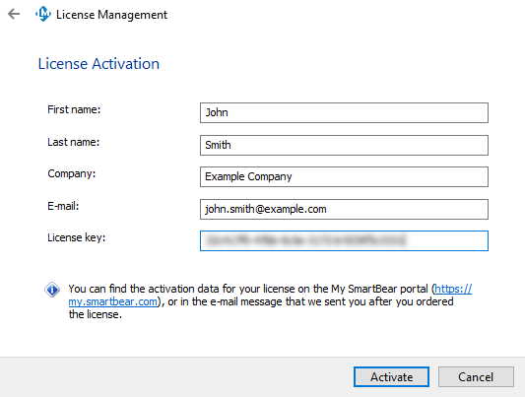

Notes:

* + You can find the license key on the TestComplete product page of the My SmartBear section of our website ([https://my.smartbear.com](https://my.smartbear.com/)) or in the email message that we sent you after you requested the license.
  + The  TestComplete Platform, Modules (Desktop, Web, Mobile), and add-ons can have separate licenses. You need to repeat the activation steps for each license key you have.
  + As for other activation data, you can either enter your username, company name, and email, or enter those of the license holder. We recommend that you enter your data.

After you have specified the activation data, click **Next** to continue.

1. If your computer connects to the Internet through a proxy server, on the next page of the wizard, enter the proxy authentication settings. Ask your system administrator for assistance if needed.
2. Click **Activate**. The wizard will activate your license.
3. If the activation is performed successfully, you will see the final page of the wizard informing you that the activation is over. You can then close the License Management wizard.

If the activation fails, the wizard will display an error message explaining the problem.

Manual activation

You use manual activation when the License Manager has no access to the SmartBear licensing website. It implies that you exchange data between them manually. For complete information, see [**Manual Activation Procedure**](https://support.smartbear.com/testcomplete/docs/licensing/key-based/activating/manual-activation.html).

(Optional) Check if activation was successful

* After the activation is over, you can check whether the license has been activated successfully. To do this, open the following URL on your License Manager computer:

<http://localhost:1947/_int_/products.html>

The activated license will be on the list:

[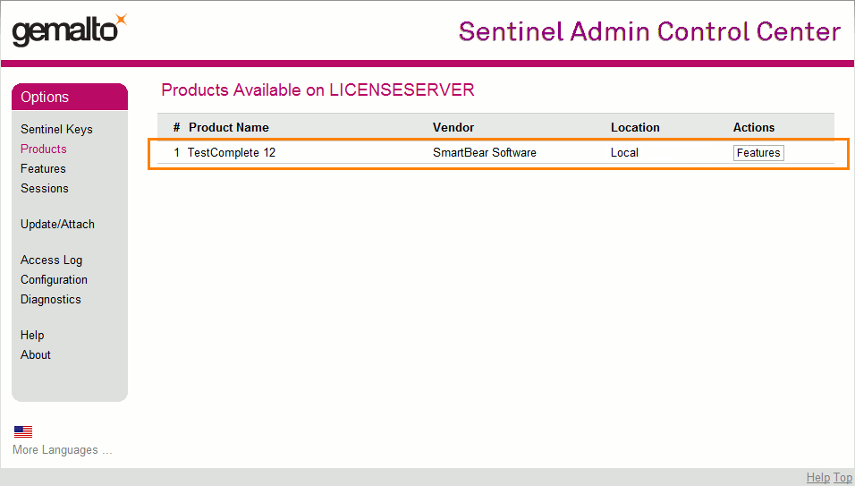](https://support.smartbear.com/testcomplete/docs/_images/licensing/list-of-available-licenses-server.png)

*Click the image to enlarge it.*

* To check if a license is available to your TestComplete instances, do the following on the computers where TestComplete is installed:
  1. On your TestComplete workstation, open the following URL in a browser —

<http://localhost:1947/_int_/products.html>

* 1. Find your Floating User license in the list. Look at the **Location** column. It should point to the License Manager machine where you activated the license:

[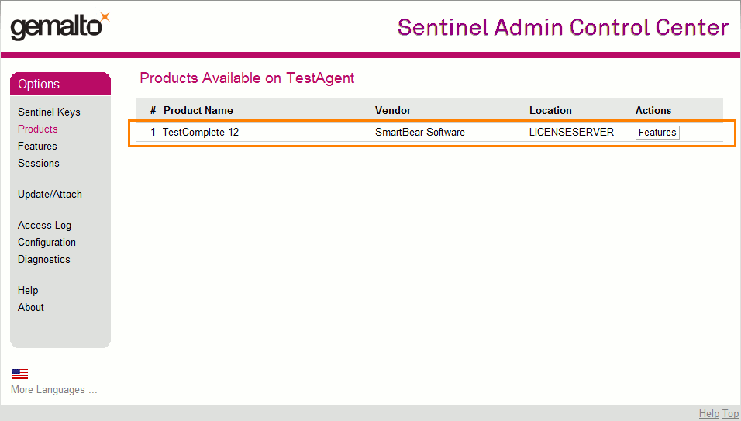](https://support.smartbear.com/testcomplete/docs/_images/licensing/list-of-available-licenses.png)

*Click the image to enlarge it.*

* If the license is not in the list, then, probably, your TestComplete workstations cannot access the License Manager computer. You may need to check the licensing settings on your computer or to ask system administrators to check the settings of proxies and firewalls running in your system. See [Fixing Typical Issues With Floating User Licenses](https://support.smartbear.com/testcomplete/docs/licensing/key-based/troubleshooting/fu-license-check-problems.html).

Where to find the License Key?

1. Login to <https://my.smartbear.com>
2. On the homepage you will get the information of products you have purchased.
3. Click on TestComplete it will redirect you to TestComplete License page where you will get the license keys.